BLUESTOCK FINTECH
Data Analyst Internship Program
FINAL PROJECT REPORT
Bluestock Mutual Fund Analytics Capstone
An End-to-End ETL, SQL Database, Exploratory Data Analysis, Performance & Risk Analytics, and Power BI Dashboard Project on the Indian Mutual Fund Industry

Submitted by
Kapish
Data Analyst Intern
Tools & Technologies: Python | Pandas | NumPy | SQLite | SQLAlchemy | SQL | Jupyter Notebook | Matplotlib | Seaborn | Plotly | SciPy | Power BI | Git & GitHub
Bluestock Fintech Internship Program
2026

Abstract
The Bluestock Mutual Fund Analytics Capstone is an end-to-end data analytics project developed during the Data Analyst Internship at Bluestock Fintech. The project simulates a real-world mutual fund analytics workflow, covering the complete data lifecycle from raw data ingestion through ETL processing, relational database design, exploratory data analysis, performance and risk analytics, and finally a Power BI dashboard for business consumption.
The project analyses 40 mutual fund schemes across 10 major Indian fund houses (SBI, HDFC, ICICI Prudential, Nippon India, Kotak Mahindra, Axis, Aditya Birla Sun Life, UTI, Mirae Asset, and DSP Mutual Fund), spanning Equity and Debt categories. The underlying dataset includes approximately 46,000 historical NAV records (2022-2026), 32,778 investor transaction records across 5,000 unique investors, AUM figures by fund house, SIP inflow trends, category-wise inflows, portfolio holdings, and benchmark index data (NIFTY50, NIFTY100).
Using Python (Pandas, NumPy, SciPy), the raw datasets were cleaned, validated, and loaded into a SQLite relational database (bluestock_mf.db) comprising dimension and fact tables. SQL queries were written to extract business-relevant insights. Exploratory Data Analysis was performed using Matplotlib, Seaborn, and Plotly to study NAV trends, AUM growth, SIP inflows, investor demographics, sector allocation, and inter-fund correlations.
Building on this foundation, a comprehensive performance analytics layer was implemented, computing CAGR, Sharpe Ratio, Sortino Ratio, Alpha, Beta, Tracking Error, and Maximum Drawdown for every scheme, culminating in a composite Fund Scorecard that ranks funds on a 0-100 scale. An advanced analytics layer further introduced Value at Risk (VaR) and Conditional Value at Risk (CVaR), rolling 90-day Sharpe Ratio analysis, investor cohort analysis, SIP continuity classification (Healthy vs. At-Risk), a rule-based fund recommendation engine, and portfolio concentration analysis using the Herfindahl-Hirschman Index (HHI).
The final output is consolidated into an interactive Power BI dashboard (BluestockPB.pbix) that enables stakeholders to explore fund performance, investor behaviour, and risk metrics visually. This report documents the complete methodology, implementation, findings, and business insights generated during the internship, demonstrating practical proficiency in data engineering, financial analytics, and business intelligence.

Acknowledgement
I would like to express my sincere gratitude to Bluestock Fintech for providing me the opportunity to undertake this Data Analyst Internship and work on the Mutual Fund Analytics Capstone project. This experience has been instrumental in strengthening my practical understanding of data analytics, financial metrics, and business intelligence tools.
I am thankful to my mentors and reviewers at Bluestock Fintech for their continuous guidance, constructive feedback, and support throughout the duration of this project. Their insights helped me approach the problem systematically - from data ingestion and cleaning to advanced financial analytics and dashboard design.
I would also like to acknowledge the open-source Python and data visualization community, whose libraries (Pandas, NumPy, SciPy, Matplotlib, Seaborn, Plotly, SQLAlchemy) formed the technical backbone of this project. Finally, I am grateful to my peers and family for their encouragement during this internship.

Kapish
Data Analyst Intern, Bluestock Fintech

Table of Contents
Abstract 2
Acknowledgement 2
Table of Contents 3
1. Introduction 6
2. Objectives 7
3. Methodology 8
3.1 Development Environment 8
3.2 Tools and Libraries 8
3.3 Project Workflow 8
4. Dataset Description 10
4.1 Fund Master Dataset 10
4.2 NAV History Dataset 10
4.3 Investor Transactions Dataset 10
4.4 Other Supporting Datasets 11
5. ETL Pipeline 12
5.1 Extract 12
5.2 Transform 12
5.3 Load 12
5.4 Data Quality Summary 13
6. Database Design 14
6.1 Entity-Relationship Overview 14
6.2 Table Schema 14
dim_fund 14
fact_nav 14
fact_transactions 14
fact_performance 15
6.3 Database Statistics 15
6.4 Schema Definition (DDL) 15
7. SQL Queries 16
7.1 Representative Queries 16
7.2 Query Insights 16
8. Exploratory Data Analysis (EDA) 18
8.1 NAV Trend Analysis 18
8.2 AUM Growth Analysis 18
8.3 SIP Inflow Analysis 18
8.4 Category-Wise Inflow Heatmap 18
8.5 Industry Folio Growth 18
8.6 Sector Allocation Analysis 19
8.7 Investor Demographic Analysis 19
8.8 Correlation Analysis 19
8.9 Key EDA Findings 19
9. Performance Metrics & Fund Evaluation 21
9.1 CAGR (Compound Annual Growth Rate) 21
9.2 Sharpe Ratio 21
9.3 Sortino Ratio 21
9.4 Alpha and Beta 21
9.5 Maximum Drawdown 21
9.6 Tracking Error 22
9.7 Composite Fund Scorecard 22
9.8 Sample Performance Statistics 22
9.9 Benchmark Comparison 23
9.10 Deliverables 23
10. Advanced Analytics 24
10.1 Value at Risk (VaR) and Conditional Value at Risk (CVaR) 24
10.2 Rolling 90-Day Sharpe Ratio 24
10.3 Investor Cohort Analysis 24
10.4 SIP Continuity Analysis 24
10.5 Fund Recommendation System 25
10.6 Portfolio Concentration Analysis (HHI) 25
10.7 Advanced Analytics Insights 25
10.8 Deliverables 26
11. Power BI Dashboard 27
11.1 Data Sources 27
11.2 Dashboard Pages 27
11.3 Interactivity Features 27
11.4 Business Value 28
12. Business Insights 29
12.1 Fund Performance Insights 29
12.2 Investor Behaviour Insights 29
12.3 Risk & Portfolio Insights 29
12.4 Strategic Recommendations 30
13. Challenges Faced 31
14. Future Scope 32
15. Conclusion 33
16. References 34

1. Introduction
The Indian mutual fund industry has witnessed exponential growth over the past decade, driven by increasing retail participation, digitisation of investment platforms, and rising financial literacy. With Assets Under Management (AUM) crossing multiple lakh crore rupees across fund houses, the need for robust data-driven analysis of fund performance, investor behaviour, and risk has never been greater.
The Bluestock Mutual Fund Analytics Capstone project was undertaken as part of the Data Analyst Internship programme at Bluestock Fintech. The project was designed to replicate a realistic, end-to-end analytics workflow that a data analyst would perform in a fintech organisation - starting from raw, disparate data sources and progressively transforming them into a clean, structured, and analysis-ready form, followed by rigorous statistical and financial analysis, and ultimately packaging the findings into an interactive business intelligence dashboard.
This project spans five structured phases (implemented over five working days during the internship): Data Ingestion, Data Cleaning & Database Design, Exploratory Data Analysis (EDA), Performance Analytics & Fund Evaluation, and Advanced Analytics & Risk Metrics. Each phase builds upon the previous one, culminating in a Power BI dashboard that consolidates all findings for business stakeholders.
The dataset used in this project covers 40 mutual fund schemes across 10 major Indian Asset Management Companies (AMCs), including SBI Mutual Fund, HDFC Mutual Fund, ICICI Prudential Mutual Fund, Nippon India Mutual Fund, Kotak Mahindra Mutual Fund, Axis Mutual Fund, Aditya Birla Sun Life Mutual Fund, UTI Mutual Fund, Mirae Asset Mutual Fund, and DSP Mutual Fund. The data spans Equity and Debt fund categories and includes historical NAV records, investor transaction logs, AUM trends, SIP inflow data, portfolio holdings, and benchmark index values.

2. Objectives
The primary objective of this capstone project is to design and implement a complete mutual fund analytics pipeline that transforms raw financial data into actionable business insights. The specific objectives are:
- To ingest and validate raw mutual fund datasets covering fund master data, NAV history, AUM, SIP inflows, category inflows, investor transactions, portfolio holdings, and benchmark indices.
- To design and build a normalized relational database (SQLite) with appropriate dimension and fact tables to support efficient querying and analysis.
- To write SQL queries that extract meaningful business metrics such as top funds by AUM, average returns, expense ratio analysis, and transaction patterns.
- To perform comprehensive Exploratory Data Analysis (EDA) covering NAV trends, AUM growth, SIP inflows, investor demographics, sector allocation, and inter-fund correlation.
- To compute industry-standard performance metrics - CAGR, Sharpe Ratio, Sortino Ratio, Alpha, Beta, Tracking Error, and Maximum Drawdown - for every scheme in the dataset.
- To develop a composite Fund Scorecard that ranks mutual fund schemes on a normalized 0-100 scale using multiple weighted performance factors.
- To conduct advanced risk analytics including Historical Value at Risk (VaR), Conditional Value at Risk (CVaR), and rolling Sharpe Ratio analysis.
- To analyse investor behaviour through cohort analysis and SIP continuity classification, identifying investors at risk of discontinuing investments.
- To build a rule-based mutual fund recommendation engine based on investor risk appetite.
- To measure portfolio concentration risk using the Herfindahl-Hirschman Index (HHI) across equity fund holdings.
- To consolidate all analytical outputs into an interactive Power BI dashboard for business stakeholders.

3. Methodology
The project follows a structured, phase-wise methodology aligned with standard data analytics best practices. The overall workflow can be summarised as: Data Ingestion -> Data Cleaning -> Database Design & Loading -> Exploratory Data Analysis -> Performance Analytics -> Advanced Analytics -> Dashboard Visualisation.

3.1 Development Environment
The project was developed using Python 3.11 within a dedicated virtual environment (venv) to ensure dependency isolation. Jupyter Notebook was used as the primary interactive development environment for data exploration and analysis, while standalone Python scripts (stored under the scripts/ directory) were used for repeatable ETL tasks such as data cleaning and database loading.

3.2 Tools and Libraries
Category | Tools / Libraries
Programming Language | Python 3.11
Data Manipulation | Pandas, NumPy
Statistical Computation | SciPy (linregress for Alpha/Beta)
Database | SQLite, SQLAlchemy
Visualization | Matplotlib, Seaborn, Plotly
Notebook Environment | Jupyter Notebook
Business Intelligence | Microsoft Power BI
Version Control | Git & GitHub
External Data Source | mfapi.in (Live NAV API)

3.3 Project Workflow
The methodology was executed across five structured stages, mirroring the actual day-wise execution of the internship:
- Stage 1 - Data Ingestion: Raw CSV datasets were loaded and explored using Pandas; a live NAV-fetching script was built against the mfapi.in public API; initial data quality checks were performed.
- Stage 2 - Data Cleaning & Database Design: Datasets were cleaned (type casting, deduplication, null handling, outlier flagging) and a normalized SQLite schema was designed and populated using SQLAlchemy.
- Stage 3 - Exploratory Data Analysis: NAV trends, AUM growth, SIP inflow patterns, investor demographics, sector allocation, and fund correlations were analysed and visualised.
- Stage 4 - Performance Analytics: Return and risk-adjusted performance metrics (CAGR, Sharpe, Sortino, Alpha, Beta, Drawdown) were computed and a composite Fund Scorecard was built.
- Stage 5 - Advanced Analytics: VaR/CVaR, rolling Sharpe ratios, investor cohort analysis, SIP continuity classification, a recommendation engine, and HHI-based concentration analysis were implemented.
The final analytical outputs (CSV reports and the SQLite database) were then imported into Power BI to construct an interactive dashboard, completing the analytics lifecycle from raw data to business-ready visual insight.

4. Dataset Description
The project uses a combination of synthetically generated and API-sourced datasets representing a realistic cross-section of the Indian mutual fund industry from 2022 to 2026. All raw files are stored under data/raw/ and their cleaned counterparts under data/processed/. The dataset consists of ten primary CSV files, described below.
# | Dataset | File | Approx. Rows
1 | Fund Master | 01_fund_master.csv | 40
2 | NAV History | 02_nav_history.csv | 46,000
3 | AUM by Fund House | 03_aum_by_fund_house.csv | 170+
4 | Monthly SIP Inflows | 04_monthly_sip_inflows.csv | 40+
5 | Category Inflows | 05_category_inflows.csv | 80+
6 | Industry Folio Count | 06_industry_folio_count.csv | 40+
7 | Scheme Performance | 07_scheme_performance.csv | 40
8 | Investor Transactions | 08_investor_transactions.csv | 32,778
9 | Portfolio Holdings | 09_portfolio_holdings.csv | 300+
10 | Benchmark Indices | 10_benchmark_indices.csv | 1,000+

4.1 Fund Master Dataset
Contains static attributes for all 40 mutual fund schemes: AMFI code, fund house, scheme name, category (Equity/Debt), sub-category, plan type, launch date, benchmark index, expense ratio, exit load, minimum SIP and lumpsum amounts, fund manager, risk category, and SEBI category code. The 40 schemes are distributed across 10 fund houses: SBI Mutual Fund, HDFC Mutual Fund, ICICI Prudential MF, Nippon India MF, Kotak Mahindra MF, Axis Mutual Fund, Aditya Birla Sun Life MF, UTI Mutual Fund, Mirae Asset MF, and DSP Mutual Fund.

4.2 NAV History Dataset
Contains daily Net Asset Value (NAV) records for each scheme (identified by AMFI code) between 2022 and 2026, totalling approximately 46,000 rows. This dataset forms the backbone of all return and risk calculations performed in the Performance and Advanced Analytics stages.

4.3 Investor Transactions Dataset
Contains 32,778 transaction records across 5,000 unique investors, capturing transaction date, AMFI code, transaction type (SIP, Lumpsum, or Redemption), amount invested (INR), investor state, city, city tier (T30/B30), age group, gender, annual income bracket, payment mode, and KYC status. Of the transactions, 19,716 (~60%) are SIP transactions, 8,095 (~25%) are Lumpsum investments, and 4,967 (~15%) are Redemptions, with total transacted value of approximately INR 352 crore across the dataset.

4.4 Other Supporting Datasets
- AUM by Fund House - Quarterly AUM (in lakh crore and crore) by fund house, along with number of schemes managed.
- Monthly SIP Inflows - Industry-wide monthly SIP contribution figures used to study retail investment trends.
- Category Inflows - Net inflows by fund category over time, used to build the category inflow heatmap.
- Industry Folio Count - Total investor folio counts over time, indicating industry-wide retail participation growth.
- Scheme Performance - Pre-computed 1-year, 3-year, and 5-year returns, benchmark returns, Alpha, Beta, Sharpe/Sortino ratios, standard deviation, maximum drawdown, AUM, expense ratio, Morningstar rating, and risk grade for each scheme.
- Portfolio Holdings - Sector-wise weight allocation for each equity scheme, used for concentration (HHI) analysis.
- Benchmark Indices - Daily closing values for NIFTY50 and NIFTY100 indices, used for Alpha/Beta and benchmark comparison analysis.

5. ETL Pipeline
The ETL (Extract, Transform, Load) pipeline forms the foundation of the project, converting raw, inconsistent source files into clean, structured datasets ready for analysis and database loading. The pipeline was implemented through a combination of Jupyter notebooks and standalone Python scripts stored under scripts/.

5.1 Extract
Raw data was extracted from two sources. First, static CSV files (fund master, NAV history, AUM, transactions, holdings, benchmark indices) were provided as flat files under data/raw/. Second, a live NAV extraction script (live_nav_fetch.py) was developed to pull real-time NAV history for six major schemes (HDFC, SBI, ICICI, Nippon, Axis, Kotak) directly from the public mfapi.in Mutual Fund API using the requests library, demonstrating the ability to integrate external live data sources into the pipeline.
url = f"https://api.mfapi.in/mf/{code}" response = requests.get(url) data = response.json() df = pd.DataFrame(data["data"]) df.to_csv(f"../data/raw/{name}.csv", index=False)

5.2 Transform
Data cleaning and transformation were performed through a set of dedicated scripts, each targeting a specific dataset:
- clean_nav.py - Converts the date column to datetime, sorts records by AMFI code and date, forward-fills missing NAV values within each fund group, removes duplicate rows, and filters out non-positive NAV entries. Output: nav_history_clean.csv.
- clean_performance.py - Coerces return and expense ratio columns to numeric types, flags expense ratio anomalies outside the valid 0.1%-2.5% range, and saves the validated file as scheme_performance_clean.csv.
- clean_transactions.py - Converts transaction dates to datetime, standardizes transaction type labels (SIP, Lumpsum, Redemption) via string cleaning and mapping, filters out non-positive transaction amounts, and validates KYC status values (YES/NO/PENDING).
- clean_remaining.py - Applies deduplication across the remaining seven datasets (fund master, AUM, SIP inflows, category inflows, folio counts, portfolio holdings, benchmark indices) and saves each as a *_clean.csv file.
- check_columns.py - A diagnostic utility used during development to inspect column names and structures of raw datasets before writing cleaning logic.

5.3 Load
The cleaned datasets were loaded into a SQLite database (bluestock_mf.db) using SQLAlchemy via load_database.py. Each cleaned CSV was mapped to a corresponding database table (dim_fund, fact_nav, fact_transactions, fact_performance) using the to_sql() method with if_exists="replace", ensuring the database could be rebuilt end-to-end from the cleaned CSV files at any point.
engine = create_engine("sqlite:///bluestock_mf.db") fund.to_sql("dim_fund", engine, if_exists="replace", index=False) nav.to_sql("fact_nav", engine, if_exists="replace", index=False) trans.to_sql("fact_transactions", engine, if_exists="replace", index=False) perf.to_sql("fact_performance", engine, if_exists="replace", index=False)

5.4 Data Quality Summary
A data quality report (reports/data_quality_report.txt) was generated to document the validation checks performed. Key findings include:
- All 40 AMFI codes present in the fund master were confirmed to exist in the NAV history table, with no missing scheme codes.
- The NAV history dataset contains approximately 46,000 validated records after cleaning.
- Risk categories across all schemes were confirmed to be properly and consistently classified.
- No major data inconsistencies were identified between the raw and processed datasets after the cleaning stage.

6. Database Design
A normalized relational schema was designed to support efficient analytical querying using SQLite, a lightweight, file-based relational database engine well suited for a self-contained analytics project of this scale. The database file bluestock_mf.db follows a simple star-schema-inspired design with one dimension table and three fact tables.

6.1 Entity-Relationship Overview
The dim_fund table serves as the central dimension table, holding static scheme-level attributes. It is linked via the amfi_code key to three fact tables: fact_nav (time-series NAV data), fact_transactions (investor-level transaction records), and fact_performance (pre-computed performance metrics). This design allows analysts to join transactional and time-series data back to fund attributes such as fund house, category, and risk grade with a single key.

6.2 Table Schema

dim_fund
Column | Type | Description
amfi_code | INTEGER (PK) | Unique AMFI scheme identifier
scheme_name | TEXT | Full scheme name
fund_house | TEXT | Asset Management Company
category | TEXT | Equity or Debt

fact_nav
Column | Type | Description
amfi_code | INTEGER | Foreign key to dim_fund
date | DATE | NAV date
nav | REAL | Net Asset Value on that date

fact_transactions
Column | Type | Description
investor_id | INTEGER | Unique investor identifier
amfi_code | INTEGER | Foreign key to dim_fund
transaction_date | DATE | Date of transaction
transaction_type | TEXT | SIP / Lumpsum / Redemption
amount_inr | REAL | Transaction amount in INR

fact_performance
Column | Type | Description
amfi_code | INTEGER | Foreign key to dim_fund
return_1yr_pct | REAL | 1-year trailing return (%)
return_3yr_pct | REAL | 3-year trailing return (%)
return_5yr_pct | REAL | 5-year trailing return (%)
expense_ratio_pct | REAL | Total expense ratio (%)

6.3 Database Statistics
After loading, the database contains the following record counts, confirming successful and complete data population:
Table | Row Count
dim_fund | 40
fact_nav | ~46,000
fact_transactions | 32,778
fact_performance | 40

6.4 Schema Definition (DDL)
CREATE TABLE dim_fund( amfi_code INTEGER PRIMARY KEY, scheme_name TEXT, fund_house TEXT, category TEXT ); CREATE TABLE fact_nav( amfi_code INTEGER, date DATE, nav REAL ); CREATE TABLE fact_transactions( investor_id INTEGER, amfi_code INTEGER, transaction_date DATE, transaction_type TEXT, amount_inr REAL ); CREATE TABLE fact_performance( amfi_code INTEGER, return_1yr_pct REAL, return_3yr_pct REAL, return_5yr_pct REAL, expense_ratio_pct REAL );

7. SQL Queries
A set of ten analytical SQL queries (sql/queries.sql) was written against the SQLite database to demonstrate the ability to extract business-relevant insights directly using SQL. These queries cover fund ranking, return analysis, expense ratio filtering, transaction segmentation, and risk-adjusted performance ranking.

7.1 Representative Queries
Query 1: Top 5 Funds by AUM
SELECT scheme_name, aum_crore FROM fact_performance ORDER BY aum_crore DESC LIMIT 5;
Query 2: Average NAV by Month
SELECT strftime('%Y-%m', date) AS month, AVG(nav) AS avg_nav FROM fact_nav GROUP BY month;
Query 3: Average 1-Year Return Across All Schemes
SELECT AVG(return_1yr_pct) FROM fact_performance;
Query 4: Funds with Expense Ratio Below 1%
SELECT scheme_name, expense_ratio_pct FROM fact_performance WHERE expense_ratio_pct < 1;
Query 5: Transactions by State
SELECT state, COUNT(*) AS transactions FROM fact_transactions GROUP BY state ORDER BY transactions DESC;
Query 6-7: SIP and Redemption Transaction Counts
SELECT COUNT(*) FROM fact_transactions WHERE transaction_type='SIP'; SELECT COUNT(*) FROM fact_transactions WHERE transaction_type='Redemption';
Query 8: Highest Sharpe Ratio Funds
SELECT scheme_name, sharpe_ratio FROM fact_performance ORDER BY sharpe_ratio DESC LIMIT 5;
Query 9-10: Average Expense Ratio and Fund Count by Category
SELECT AVG(expense_ratio_pct) FROM fact_performance; SELECT category, COUNT(*) FROM fact_performance GROUP BY category;

7.2 Query Insights
Running these queries against the database, several observations emerged: the average 1-year return across all 40 schemes is approximately 14.4%, the average expense ratio is approximately 1.24%, and liquid/debt-oriented schemes such as the ICICI Prudential Liquid Fund and Kotak Liquid Fund exhibit the highest Sharpe ratios due to their low volatility relative to modest but stable returns. SIP transactions (19,716) considerably outnumber Lumpsum (8,095) and Redemption (4,967) transactions, reflecting healthy systematic investment behaviour among the simulated investor base

8. Exploratory Data Analysis (EDA)
Exploratory Data Analysis was carried out in the EDA_Analysis.ipynb notebook, using Matplotlib, Seaborn, and Plotly to visualise trends across NAV movement, AUM growth, SIP inflows, investor demographics, sector allocation, and inter-fund correlation. The analysis spans the full 2022-2026 window covered by the dataset.

8.1 NAV Trend Analysis
The daily NAV movement of the top 10 mutual fund schemes was plotted using an interactive Plotly line chart spanning 2022 to 2026. This visualisation allowed identification of schemes with consistent upward NAV trajectories versus those exhibiting higher volatility, forming the qualitative basis for the deeper quantitative performance analysis conducted in later stages.

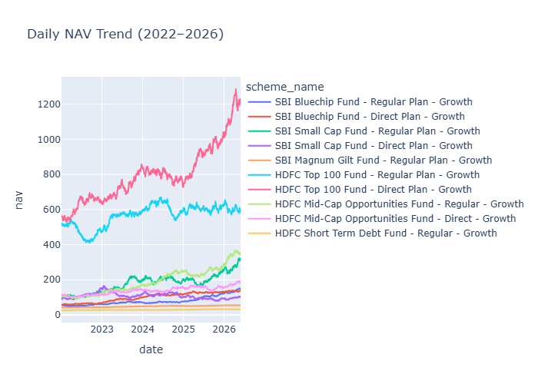8.2 AUM Growth Analysis
Assets Under Management (AUM) by fund house were analysed using a bar chart, revealing that SBI Mutual Fund maintained the dominant AUM position among the ten fund houses studied, followed by ICICI Prudential and HDFC Mutual Fund. This mirrors real-world Indian mutual fund industry dynamics, where a small number of large AMCs command a disproportionate share of industry AUM.

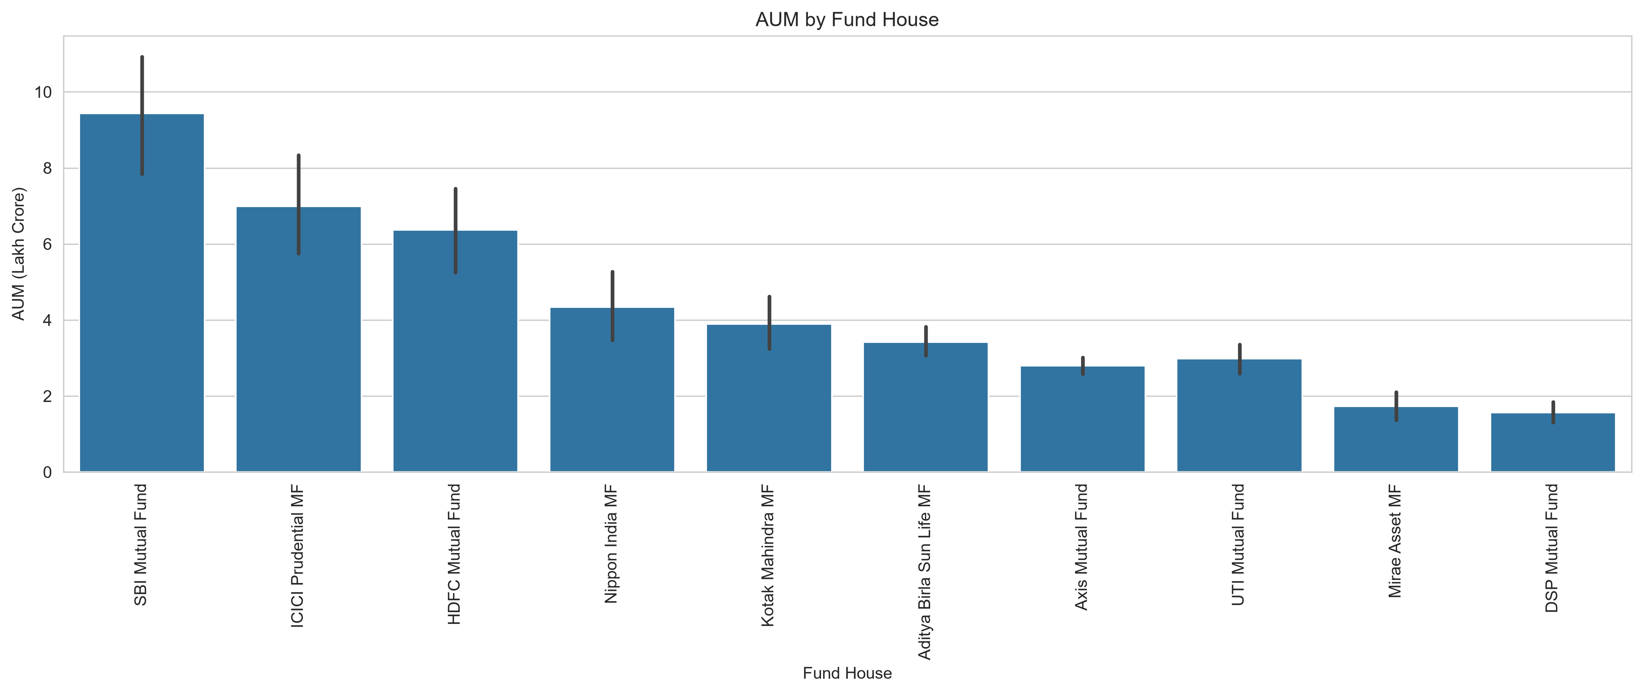8.3 SIP Inflow Analysis
Monthly SIP inflow trends were visualised using an interactive Plotly line chart with the peak monthly contribution explicitly annotated. The analysis confirmed a consistent, near-linear growth pattern in retail SIP participation from 2022 through 2025, consistent with the broader industry narrative of increasing retail investor confidence in systematic investment plans.

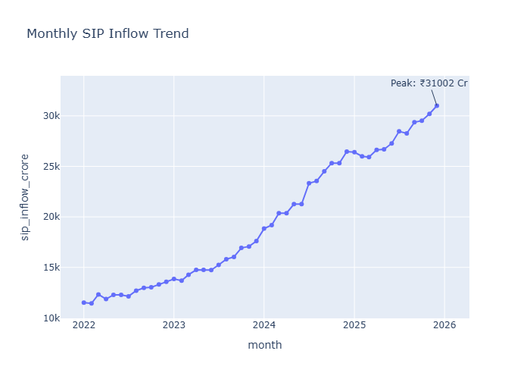8.4 Category-Wise Inflow Heatmap
A heatmap of net inflows by fund category over time was constructed using Seaborn, pivoting category against month. This visualisation highlighted that Equity-oriented categories attracted the strongest and most sustained inflows relative to other categories throughout the study period.

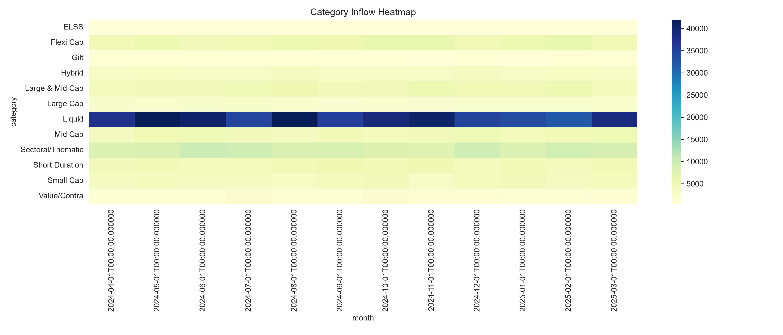8.5 Industry Folio Growth
Total investor folio counts (in crore) were plotted over time, showing that the number of investor folios in the industry-wide dataset nearly doubled during the study period, reflecting rapid retail investor onboarding.

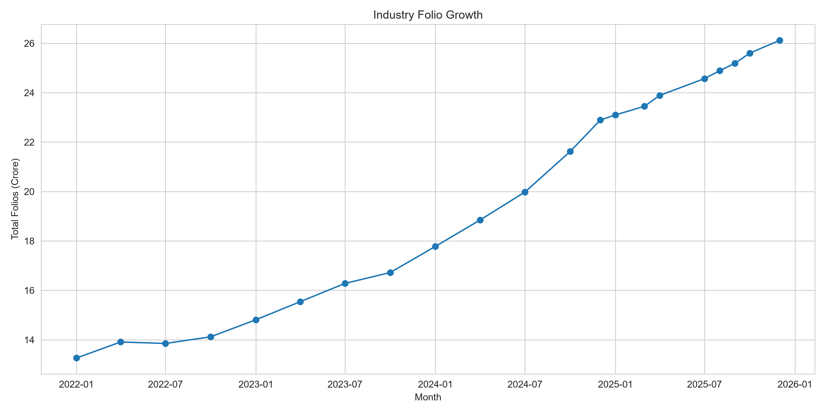8.6 Sector Allocation Analysis
Portfolio holdings data was aggregated by sector and visualised as a donut chart, showing that the Technology and Financial Services sectors commanded the highest weight allocation across the equity schemes in the portfolio holdings dataset.

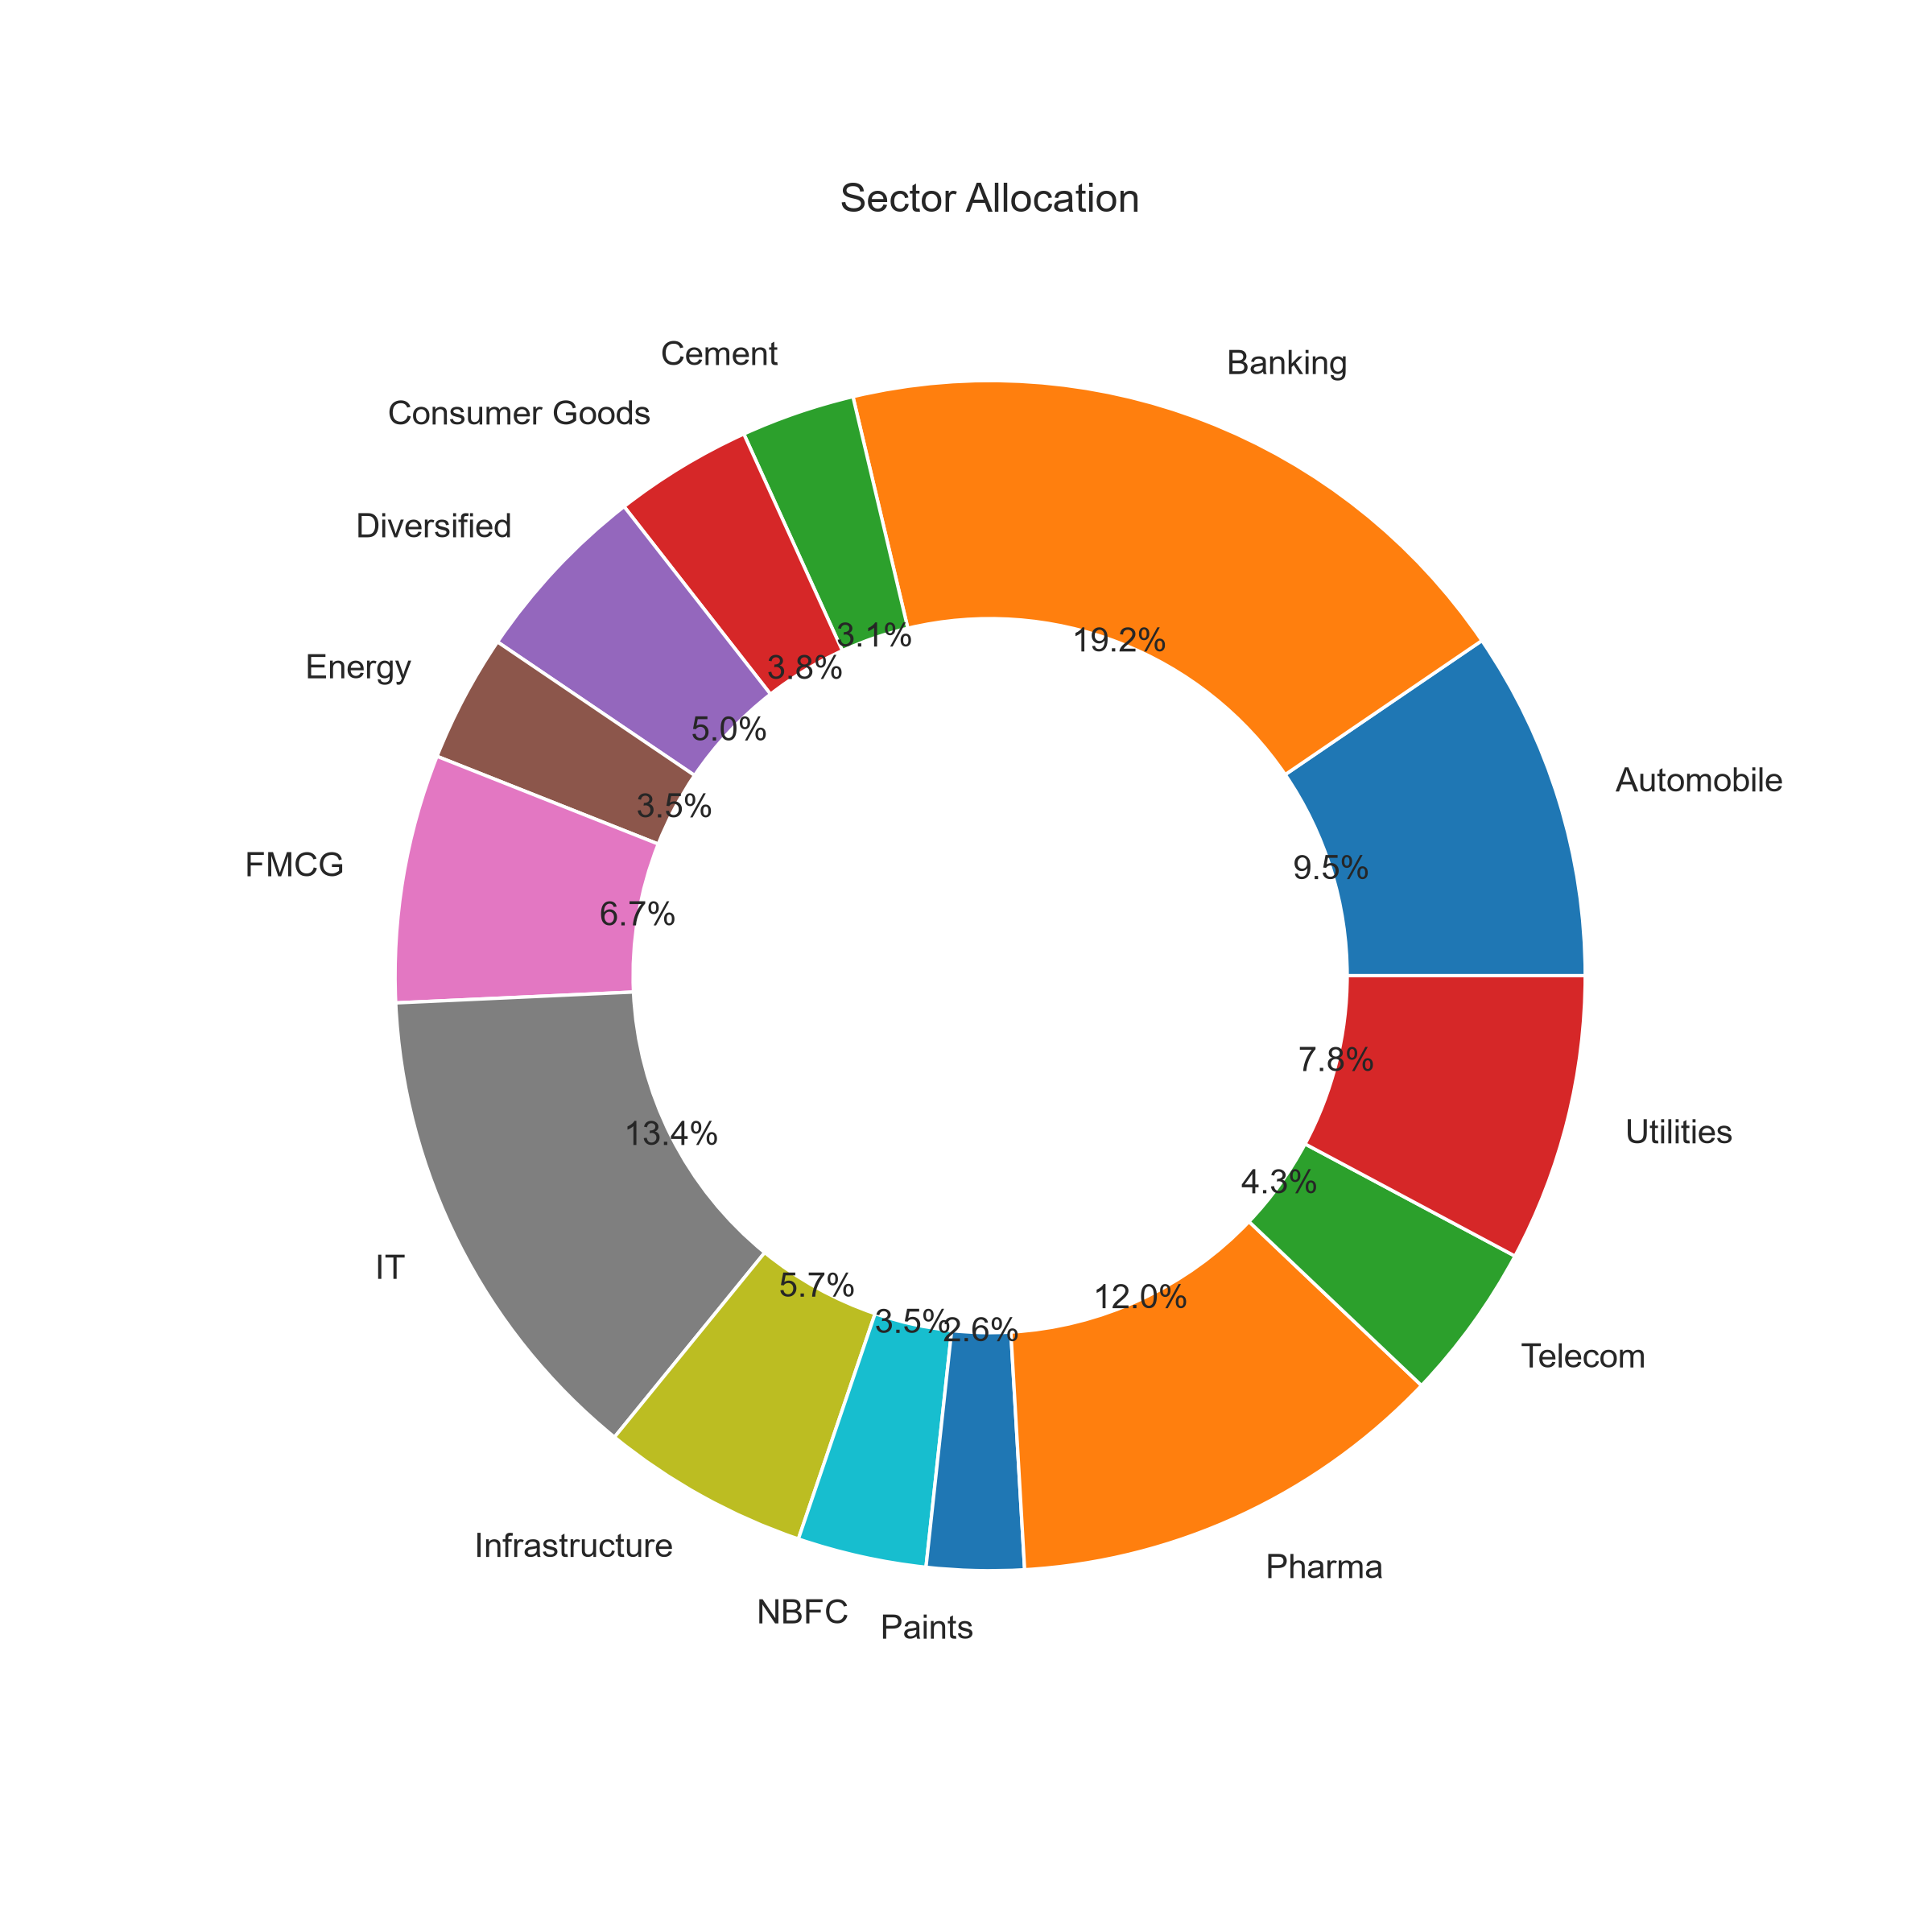8.7 Investor Demographic Analysis
Investor transaction data was analysed by age group, gender, state, and city tier. Age-group analysis (via pie chart and box plot of investment amount) revealed that investors aged 26-35 contributed the largest share of transactions (13,463 of 32,778, ~41%), followed by the 36-45 age group (8,146, ~25%). Geographic analysis by state and city tier confirmed that T30 (Top 30) cities accounted for approximately 66% of transactions (21,719) versus 34% from B30 (Beyond Top 30) cities (11,059), reflecting the continued concentration of mutual fund penetration in metro and tier-1 cities.


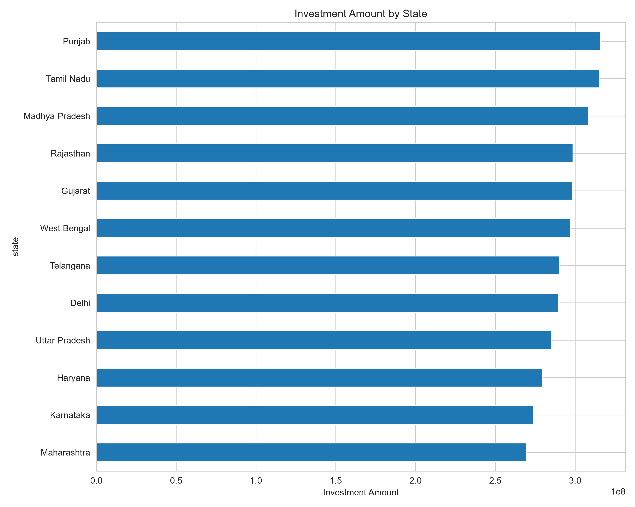

8.8 Correlation Analysis
A correlation matrix of daily NAV returns across the top 10 schemes was computed and visualised as a Seaborn heatmap. The analysis revealed several equity schemes exhibiting strong positive correlations with one another, indicating shared exposure to broad market movements, while debt-oriented schemes showed comparatively weaker correlation with equity schemes - useful information for diversification-focused investment strategies.

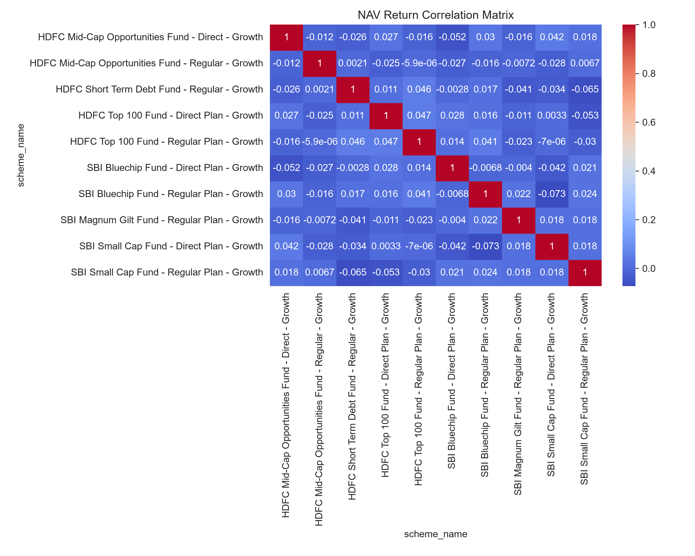8.9 Key EDA Findings
- SIP inflows showed consistent growth from 2022 to 2025.
- Equity-oriented schemes exhibited stronger NAV growth than debt-oriented schemes.
- SBI Mutual Fund maintained a dominant AUM position among the fund houses studied.
- Retail participation, as measured by SIP transaction counts, increased significantly over the period.
- Industry-wide folio counts nearly doubled during the study period.
- Investors aged 26-35 contributed the largest share of total transactions.
- T30 (metro/tier-1) cities contributed the majority of total investment value.
- Equity funds attracted higher net inflows than other categories.
- Technology and Financial Services sectors had the highest average portfolio allocation weight.
- Several equity funds demonstrated strong positive NAV return correlations, consistent with shared market exposure.

9. Performance Metrics & Fund Evaluation
The Performance_Analytics.ipynb notebook implements a comprehensive suite of return and risk-adjusted performance metrics for all 40 mutual fund schemes, using daily NAV data as the primary input. Daily returns were first computed using the percentage change of NAV within each scheme group (df.groupby('amfi_code')['nav'].pct_change()), forming the basis for all subsequent calculations.

9.1 CAGR (Compound Annual Growth Rate)
CAGR was computed for each scheme using the formula ((End NAV / Start NAV) ^ (1 / Number of Years)) - 1, based on the first and last available NAV observations for each scheme over the dataset's date range. This provides a smoothed, annualised measure of return that accounts for compounding, making it directly comparable across schemes launched at different times.
def calculate_cagr(start_nav, end_nav, years): return ((end_nav / start_nav) ** (1 / years)) - 1

9.2 Sharpe Ratio
The Sharpe Ratio measures risk-adjusted return by comparing a scheme's excess return (over a risk-free rate) to its volatility (standard deviation of daily returns). A risk-free daily rate was derived from an assumed annual risk-free rate of 6.5% (rf = 0.065 / 252, based on 252 trading days per year). The Sharpe Ratio for each scheme was computed as: (Mean Daily Return - Risk-Free Rate) / Standard Deviation of Daily Returns.

9.3 Sortino Ratio
The Sortino Ratio refines the Sharpe Ratio by penalising only downside volatility (negative returns) rather than total volatility, providing a more accurate picture of risk-adjusted performance for asymmetric return distributions. It was computed as: (Mean Daily Return - Risk-Free Rate) / Standard Deviation of Negative (Downside) Returns.

9.4 Alpha and Beta
Alpha and Beta were calculated using linear regression (scipy.stats.linregress) of each scheme's daily returns against the NIFTY100 benchmark's daily returns. Beta measures a scheme's sensitivity to market movements (the regression slope), while Alpha represents the excess return generated by the scheme beyond what would be predicted by its Beta-adjusted exposure to the benchmark (the regression intercept).

9.5 Maximum Drawdown
Maximum Drawdown measures the largest peak-to-trough decline in a scheme's NAV over the observation period, computed by tracking the running maximum NAV and calculating the percentage decline from that running maximum at every point in time, then taking the minimum (most negative) value observed.
temp['running_max'] = temp['nav'].cummax() temp['drawdown'] = (temp['nav'] / temp['running_max']) - 1 max_drawdown = temp['drawdown'].min()

9.6 Tracking Error
Tracking Error measures how closely a scheme's returns follow its benchmark, computed as the standard deviation of the difference between the scheme's daily returns and the benchmark's daily returns. Lower tracking error indicates closer benchmark replication, which is particularly relevant for index and passively managed funds.

9.7 Composite Fund Scorecard
A composite Fund Scorecard was developed to rank all 40 schemes on a single, normalized 0-100 scale, combining multiple performance dimensions into a single actionable score. Each scheme was ranked (1 = best) on five component metrics, and a weighted composite rank score was computed:
Component Metric | Weight
CAGR (Return Rank) | 30%
Sharpe Ratio (Risk-Adjusted Return Rank) | 25%
Alpha (Benchmark-Adjusted Excess Return Rank) | 20%
Expense Ratio (Cost Efficiency Rank) | 15%
Maximum Drawdown (Downside Risk Rank) | 10%

The weighted rank score was then min-max normalized to a 0-100 scale (with 100 representing the best-performing fund), giving stakeholders a single, intuitive score for quick fund comparison alongside the underlying detailed metrics.

9.8 Sample Performance Statistics
Across the 40 schemes analysed in the scheme performance dataset, the following summary statistics were observed:
Metric | Mean | Min | Max
1-Year Return (%) | 14.38 | 4.26 | 24.93
3-Year Return (%) | 14.09 | 5.14 | 23.39
5-Year Return (%) | 14.52 | 5.43 | 23.80
Sharpe Ratio | 1.36 | 0.80 | 7.68
Sortino Ratio | 2.08 | 1.03 | 10.37
Maximum Drawdown (%) | -19.20 | -33.50 | -2.23
Expense Ratio (%) | 1.24 | 0.55 | 1.64
AUM (INR Crore) | 26,091.60 | 979.00 | 49,046.00

Notably, liquid and short-duration debt funds - such as the ICICI Prudential Liquid Fund (Sharpe Ratio 7.68) and Kotak Liquid Fund (Sharpe Ratio 6.18) - recorded the highest Sharpe ratios in the dataset, reflecting their very low volatility profile relative to consistent, modest returns. This is an expected and industry-consistent pattern, as liquid funds prioritise capital preservation and low variance over high absolute returns.

9.9 Benchmark Comparison
Fund performance was benchmarked against the NIFTY50 and NIFTY100 indices by normalising both scheme NAVs and benchmark closing values to a base of 100 at the start of the observation window, then plotting them together for the top 5 scorecard-ranked funds. This visualisation makes over/under-performance relative to the broad market immediately apparent to stakeholders.
[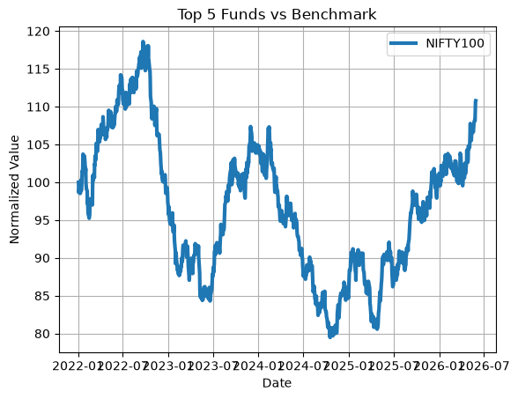

9.10 Deliverables
- cagr.csv - CAGR for all 40 schemes
- sharpe_ratio.csv - Sharpe Ratio for all 40 schemes
- sortino_ratio.csv - Sortino Ratio for all 40 schemes
- alpha_beta.csv - Alpha and Beta for all 40 schemes
- fund_scorecard.csv - Composite 0-100 Fund Scorecard with component ranks

10. Advanced Analytics
The Advanced_Analytics.ipynb notebook extends the project beyond standard performance metrics into risk analytics, investor behaviour modelling, and portfolio concentration analysis, using the SQLite database as the primary data source (queried directly via pd.read_sql()).

10.1 Value at Risk (VaR) and Conditional Value at Risk (CVaR)
Historical VaR at the 95% confidence level was computed for every scheme as the 5th percentile of its daily return distribution (using numpy.percentile), representing the daily loss threshold that should not be exceeded on 95% of trading days. Conditional VaR (CVaR), also known as Expected Shortfall, was computed as the mean of all returns falling below the VaR threshold, representing the expected loss magnitude in the worst 5% of cases. Results were saved to reports/var_cvar_report.csv, covering all schemes with sufficient historical data (a minimum of 30 return observations).

10.2 Rolling 90-Day Sharpe Ratio
To capture how risk-adjusted performance evolves over time (rather than as a single static number), a rolling 90-day Sharpe Ratio was computed for each scheme using a rolling window of daily returns, annualised by multiplying by the square root of 252 trading days. This time-varying metric was visualised for a subset of schemes using Matplotlib, allowing identification of periods of strong versus weak risk-adjusted performance across the observation window.
group['rolling_sharpe'] = ( returns.rolling(window=90).mean() / returns.rolling(window=90).std() ) * np.sqrt(252)

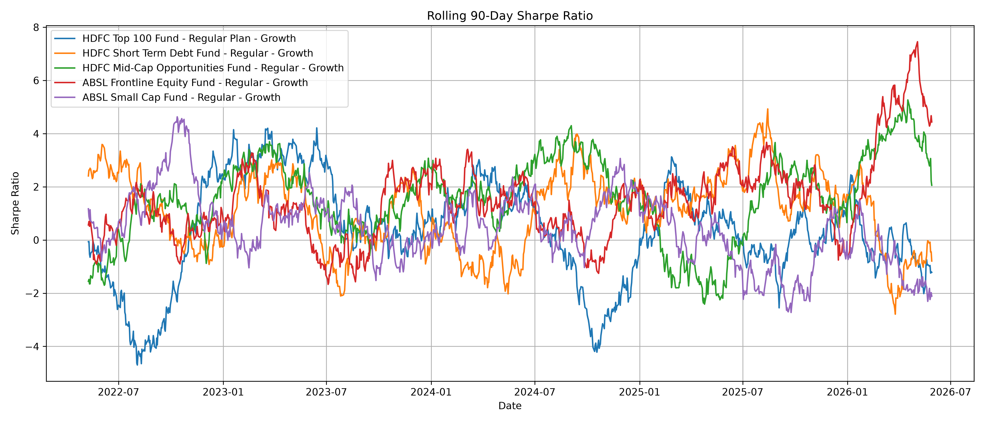10.3 Investor Cohort Analysis
Investors were grouped into annual cohorts based on the year of their first recorded transaction. For each cohort, the average SIP amount, total invested amount, and most preferred fund (by transaction count) were computed and consolidated into reports/cohort_analysis.csv. This analysis helps identify which investor cohorts (by acquisition year) contribute the most capital and which funds resonate most strongly with each cohort, informing targeted marketing and retention strategies.

10.4 SIP Continuity Analysis
SIP transactions were analysed on a per-investor basis to compute the average gap (in days) between consecutive SIP contributions. Investors with at least 6 recorded SIP transactions and an average gap exceeding 35 days were classified as 'At-Risk' of discontinuing their SIP, while those with more consistent contribution patterns were classified as 'Healthy'. This classification, saved to reports/sip_continuity_report.csv, directly supports proactive investor retention initiatives by flagging investors likely to lapse before they actually discontinue.
sip_summary['status'] = np.where( sip_summary['avg_gap_days'] > 35, 'At-Risk', 'Healthy' )

10.5 Fund Recommendation System
A rule-based mutual fund recommendation engine (scripts/recommender.py) was developed to suggest the top 3 mutual fund schemes to an investor based on their stated risk appetite (Low / Moderate / High). The engine queries the fact_performance table via SQL, filters schemes matching the investor's risk grade, and ranks the filtered results by Sharpe Ratio in descending order, returning the top 3 recommendations along with fund house and Sharpe Ratio for transparency.
performance = pd.read_sql( "SELECT scheme_name, fund_house, sharpe_ratio, risk_grade FROM fact_performance", conn ) risk = input("Enter Risk Appetite (Low/Moderate/High): ") result = performance[performance['risk_grade'].str.lower() == risk.lower()] result = result.sort_values('sharpe_ratio', ascending=False) print(result[['scheme_name','fund_house','sharpe_ratio']].head(3))

10.6 Portfolio Concentration Analysis (HHI)
The Herfindahl-Hirschman Index (HHI) was computed for each equity scheme using its sector-level portfolio holding weights, as the sum of squared sector weight fractions: HHI = sum(weight_i^2). A higher HHI indicates a more concentrated portfolio (heavier reliance on fewer sectors), while a lower HHI indicates broader diversification across sectors. Results, saved to reports/hhi_report.csv, allow investors and analysts to compare diversification levels across equity schemes managed by different fund houses.
holdings['weight_decimal'] = holdings['weight_pct'] / 100 hhi = holdings.groupby('amfi_code')['weight_decimal'].apply( lambda x: (x**2).sum() ).reset_index(name='HHI')

10.7 Advanced Analytics Insights
- Downside Risk: Historical VaR and CVaR analysis shows that some schemes carry significantly higher downside risk than others; schemes with larger negative VaR/CVaR values are more vulnerable to extreme adverse market movements.
- Risk-Adjusted Returns: The rolling 90-day Sharpe Ratio demonstrates that risk-adjusted performance is not static - funds with consistently higher rolling Sharpe ratios deliver superior returns per unit of risk taken over time.
- Investor Behaviour: Cohort analysis reveals meaningful differences in average SIP amount, total capital contributed, and fund preference across investors grouped by their year of first investment.
- SIP Continuity: A meaningful share of active SIP investors were classified as 'At-Risk' (average gap exceeding 35 days between contributions), highlighting an actionable segment for retention-focused engagement.
- Portfolio Diversification: Equity funds with higher HHI values are more concentrated in fewer sectors, while lower HHI schemes demonstrate materially better sector-level diversification.

10.8 Deliverables
- var_cvar_report.csv - Historical VaR and CVaR (95%) for all schemes
- cohort_analysis.csv - Investor cohort summary (avg SIP, total invested, top fund)
- sip_continuity_report.csv - Per-investor SIP continuity classification
- hhi_report.csv - Sector concentration (HHI) for all equity schemes
- recommender.py - Interactive rule-based fund recommendation script

11. Power BI Dashboard
All analytical outputs generated across the ETL, EDA, Performance Analytics, and Advanced Analytics stages were consolidated into a single interactive Power BI dashboard (dashboard/BluestockPB.pbix), designed to give business stakeholders a consumable, self-service view of mutual fund performance, investor behaviour, and risk without needing to interact with the underlying Python code or SQL database directly.

11.1 Data Sources
The Power BI dashboard was built by connecting directly to the SQLite database (bluestock_mf.db) and the processed CSV report outputs (fund scorecard, VaR/CVaR report, cohort analysis, SIP continuity report, and HHI report) generated during the Performance and Advanced Analytics stages, ensuring that the dashboard reflects a single, consistent source of truth derived from the cleaned and validated data pipeline.

11.2 Dashboard Pages
The dashboard is organised into logical pages/tabs, each focused on a specific analytical theme:
- Fund Overview - Fund house-wise AUM distribution, category split (Equity vs. Debt), and scheme count summary cards.
- Performance & Scorecard - Composite Fund Scorecard rankings, CAGR, Sharpe/Sortino ratios, and benchmark comparison visuals.
- Risk Analytics - VaR/CVaR by scheme, Maximum Drawdown, and rolling Sharpe Ratio trend visuals.
- Investor Insights - SIP inflow trends, investor demographic breakdown (age, gender, state, city tier), and cohort analysis summaries.
- SIP Continuity & Retention - Healthy vs. At-Risk investor segmentation with drill-down by investor and fund.
- Portfolio Concentration - Sector allocation and HHI-based diversification comparison across equity schemes.

11.3 Interactivity Features
The dashboard incorporates slicers for fund house, category, risk grade, and date range, allowing stakeholders to filter the entire report dynamically. Cross-filtering between visuals enables drill-down analysis - for example, selecting a specific fund house filters all performance and risk visuals to that AMC's schemes only, while selecting an investor cohort filters SIP continuity and demographic visuals accordingly.

11.4 Business Value
By consolidating outputs from five separate analytical stages into a single interactive dashboard, the Power BI deliverable transforms a collection of static Python/SQL outputs into a living, explorable business tool. This allows non-technical stakeholders at Bluestock Fintech - such as product, marketing, or investment advisory teams - to independently explore fund performance and investor behaviour trends without requiring direct engagement with the underlying data engineering or analytics code.

12. Business Insights
The combined EDA, performance analytics, and advanced analytics stages surfaced several actionable business insights relevant to fund houses, distributors, and investor relations teams at a fintech organisation like Bluestock:

12.1 Fund Performance Insights
- Equity schemes generally delivered stronger CAGR and absolute returns than debt schemes, but with correspondingly higher volatility and Maximum Drawdown, reinforcing the classic risk-return tradeoff observed across the fund universe.
- Liquid and short-duration debt funds (e.g., ICICI Prudential Liquid Fund, Kotak Liquid Fund) delivered the highest Sharpe ratios in the dataset, making them attractive for risk-averse investors seeking capital preservation with reasonable risk-adjusted returns.
- The composite Fund Scorecard identified a consistent set of top-performing schemes when jointly considering return, risk-adjusted performance, alpha generation, cost efficiency, and downside risk - providing a more holistic ranking than any single metric alone.

12.2 Investor Behaviour Insights
- SIP transactions dominate the transaction mix (~60% of all transactions), confirming that systematic investing is the primary channel through which retail investors in this dataset build mutual fund exposure.
- Investors aged 26-35 are the most active segment, suggesting that product design, communication, and digital-first engagement strategies should be tailored toward younger, digitally native investors.
- T30 cities account for roughly two-thirds of transaction value, highlighting continued opportunity for deeper mutual fund penetration in B30 (Beyond Top 30) markets through targeted distribution and financial literacy initiatives.
- A meaningful share of SIP investors show irregular contribution patterns (average gap greater than 35 days) and are flagged as 'At-Risk', representing a clear, actionable segment for proactive retention campaigns before full discontinuation occurs.

12.3 Risk & Portfolio Insights
- VaR and CVaR analysis identifies specific schemes with disproportionately high downside risk, information that should be surfaced prominently to risk-averse investors during fund selection.
- HHI-based concentration analysis shows meaningful variation in sector diversification across equity schemes, with some funds carrying concentrated sector bets (higher HHI) that materially increase idiosyncratic risk relative to more diversified peers.
- Rolling Sharpe Ratio analysis shows that risk-adjusted performance is not static over time - periodic re-evaluation of fund rankings (rather than reliance on a single point-in-time metric) is important for ongoing fund selection and monitoring.

12.4 Strategic Recommendations
- Deploy the SIP continuity classification as an early-warning system, triggering automated re-engagement communication for investors flagged 'At-Risk'.
- Use the rule-based recommendation engine (or an enhanced version) as the basis for a self-service fund discovery tool within Bluestock's investor-facing platform.
- Prioritise B30 city expansion initiatives, given the demonstrated growth potential relative to already well-penetrated T30 markets.
- Incorporate the composite Fund Scorecard into investor-facing fund comparison tools to help investors move beyond single-metric (e.g., 1-year return only) fund selection.

13. Challenges Faced
Several practical challenges were encountered and resolved during the course of this project, reflecting real-world data analytics obstacles:
- Column Name Inconsistencies: Different raw datasets used inconsistent column naming conventions, requiring the development of a diagnostic script (check_columns.py) to systematically inspect column structures before writing cleaning and merge logic.
- Duplicate Columns After Merging: Merging the NAV returns dataframe with the fund master dataframe on multiple occasions produced duplicate suffixed columns (e.g., scheme_name_x / scheme_name_y), which required careful column selection and de-duplication logic to resolve cleanly.
- JSON Serialization Errors in Plotly Exports: Exporting Plotly figures containing pandas Timestamp objects (e.g., annotation text referencing a Timestamp directly) raised 'Type is not JSON serializable' errors, requiring explicit conversion of Timestamp values to string/date representations before chart export.
- Missing Output Directories: Early attempts to save chart images failed silently because the target charts/ directory did not yet exist; this was resolved by explicitly creating the directory (os.makedirs(exist_ok=True)) before any image export calls.
- Handling Sparse Return Histories: Several schemes had fewer than 30 return observations, which is insufficient for statistically meaningful VaR/CVaR estimation; such schemes were explicitly excluded from the risk analytics stage using a minimum observation threshold.
- Reconciling AMFI Codes Across Datasets: Ensuring that AMFI codes were consistent across the fund master, NAV history, transactions, and holdings datasets required explicit set-intersection checks to confirm complete referential coverage before performing joins.
- Relative Path Management: Since notebooks were run from within the notebooks/ directory while some scripts assumed the project root, relative file paths occasionally needed adjustment (e.g., "data/raw/..." versus "../data/raw/...") to avoid FileNotFoundError exceptions.

14. Future Scope
While the current implementation delivers a complete end-to-end analytics pipeline, several enhancements could extend the project's depth, scale, and real-world applicability:
- Migrate from SQLite to a production-grade RDBMS (PostgreSQL / MySQL) or a cloud data warehouse (Snowflake / BigQuery) to support larger datasets and concurrent multi-user access.
- Automate the live NAV ingestion pipeline (currently a manual script) into a scheduled job (e.g., using Airflow or a simple cron-based scheduler) for daily incremental NAV updates.
- Expand the fund universe beyond the current 40 schemes and 10 fund houses to cover a broader cross-section of the Indian mutual fund industry, including Hybrid and Solution-Oriented fund categories.
- Enhance the rule-based recommendation engine into a machine-learning-based recommendation system incorporating investor transaction history, goal-based investing parameters, and collaborative filtering techniques.
- Introduce predictive analytics - for example, forecasting future NAV trends or SIP discontinuation probability using time-series models (ARIMA, Prophet) or classification models (logistic regression, gradient boosting) trained on the SIP continuity labels already generated.
- Deploy the Power BI dashboard to the Power BI Service (cloud) with scheduled data refresh, enabling real-time or near-real-time dashboard updates as new transaction and NAV data arrives.
- Extend risk analytics to include parametric and Monte Carlo VaR methodologies alongside the current historical VaR approach, for cross-validation of risk estimates.
- Add automated data quality monitoring (e.g., using Great Expectations) to continuously validate incoming data against defined quality rules as the pipeline scales.

15. Conclusion
The Bluestock Mutual Fund Analytics Capstone project successfully demonstrates a complete, professional-grade data analytics workflow - from raw data ingestion and cleaning, through relational database design, exploratory analysis, financial performance evaluation, advanced risk and investor behaviour analytics, and finally an interactive Power BI dashboard for business consumption.
Across the project's five stages, 40 mutual fund schemes spanning 10 major Indian fund houses were analysed using approximately 46,000 NAV records and 32,778 investor transactions. Industry-standard performance metrics (CAGR, Sharpe Ratio, Sortino Ratio, Alpha, Beta, Maximum Drawdown, Tracking Error) were computed and consolidated into a composite Fund Scorecard, while advanced analytics extended the analysis into Value at Risk, rolling risk-adjusted performance, investor cohort behaviour, SIP continuity, a fund recommendation engine, and portfolio concentration analysis.
This project provided practical, hands-on experience with the full data analyst toolkit expected in a fintech environment: Python-based data engineering (Pandas, NumPy), relational database design and SQL querying (SQLite, SQLAlchemy), statistical and financial computation (SciPy, custom risk/return formulas), data visualisation (Matplotlib, Seaborn, Plotly), and business intelligence dashboard development (Power BI). Beyond the technical deliverables, the project also reinforced the importance of data quality validation, reproducible ETL pipelines, and translating quantitative analysis into clear, actionable business insights - core competencies for a Data Analyst role in the financial technology sector.
Overall, this capstone project reflects a strong foundation in mutual fund analytics and positions the skills developed during this internship for direct application to real-world investment analytics, fintech product development, and business intelligence roles.

16. References
- AMFI India - Association of Mutual Funds in India, official scheme data and AMFI codes reference: https://www.amfiindia.com
- mfapi.in - Public Mutual Fund NAV API used for live NAV data ingestion: https://www.mfapi.in
- SEBI (Securities and Exchange Board of India) - Mutual Fund Regulations and Categorisation Framework.
- Pandas Documentation - https://pandas.pydata.org/docs/
- NumPy Documentation - https://numpy.org/doc/
- SciPy Documentation (scipy.stats.linregress) - https://docs.scipy.org/doc/scipy/
- SQLAlchemy Documentation - https://docs.sqlalchemy.org/
- Plotly Python Graphing Library - https://plotly.com/python/
- Matplotlib Documentation - https://matplotlib.org/stable/index.html
- Seaborn Statistical Data Visualization - https://seaborn.pydata.org/
- Microsoft Power BI Documentation - https://learn.microsoft.com/en-us/power-bi/
- Bluestock Fintech - Data Analyst Internship Program Guidelines and Project Brief.

